# EDU App Instructions v2.1

1. Install the “splunk_education v2-1.spl” package
2. Generate a CSV file from the Mike Lennox run Education Report site for a single one of your customers. If your browser does not automatically save as a CSV but instead gives you a web page with the comma separated values displayed, do a “save as” or “save page as” depending on your browser, and save as text with a .csv extension. The .csv file name must match the following pattern   
     
   “EDU <customer> <date>.csv”  
     
   Replace <customer> with any unique string to identify your customer. Do not use spaces in the customer name.
3. 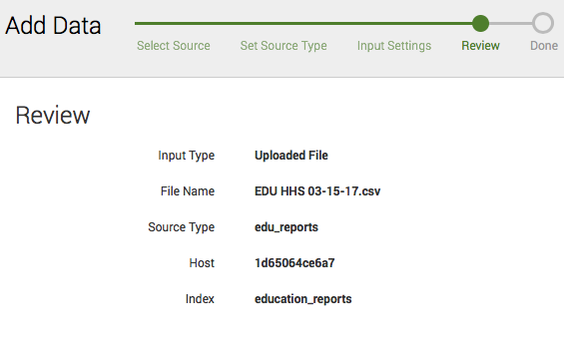Perform an “add data” in the Splunk Education app and read in the CSV file you just created. Sourcetype should be “edu_reports”. Index should be education_reports.
4. Once all the events are indexed, open the “New Student” dashboard and select the customer radio button for the file you have just create and press submit. This will create and or update, the Customer_Staff.csv lookup table.   
     
   Example results of running this dashboard:

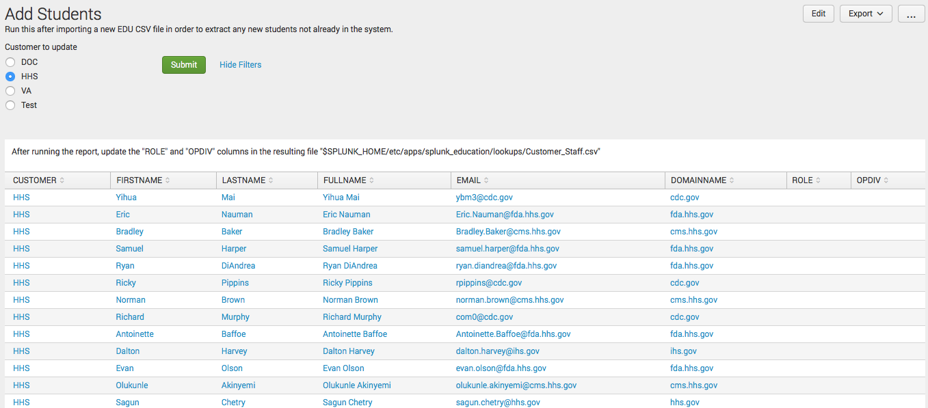

These results are saved in $SPLUNK_HOME/etc/apps/splunk_education/lookups/Customer_Staff.csv

Modify the Customer_Staff.csv file to indicate which Role and which Operating Division (OPDIV) each staff member is part of. Roles are used to track a student’s progress towards certification and should be one of the following values:

* User
* Admin
* Architect
* Security
* Dev

OPDIV can be any unique string that makes sense for that particular customer.

**NOTE:** If you don’t wish to track the education stats or progress for a particular staff member then leave OPDIV blank. This also implies that you must enter something in the OPDIV field for each staff member however or none of the dashboards that rely on specifying a division will work.

1. When refreshing data from the Education Report site to the Splunk app, repeat step 2 but manually edit the CSV file to remove any duplicate data. Note that the REGISTRATIONID field is a unique identifier and is sequentially increased by the Education Report site so you can use it to determine what the latest data is and what data you have previously imported into the Splunk. Use the following search for each of your customers to determine what data to import and what to delete from the CSV file.  
     
   eventtype=edu_report CUSTOMER="<customer>" |stats max(REGISTRATIONID)

Replace <customer> with the unique identifier you are using for your customer. This will give you back the highest Registration ID present in the Splunk app for that customer. Use this to delete all records from the CSV with a REGISTRATIONID that is less than or greater than the value produced by the search.

**NOTE:** Be sure to take care when editing the Education Report CSV file, that you do not change the format of any of the date fields. The Splunk app expects dates to be in mm/dd/yyyy format. Excel will sometimes alter the date format to mm/dd/yy when saving a CSV.

Finally, repeat step 4. This will update the Customer_Staff.csv file with any hew students present in the latest CSV file you imported. You will need to set the OPDIV and Role for these new students.